Join us for MVCA Spirit Night at
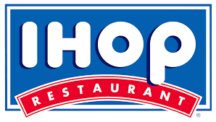
(Route 50 – Winchester)

Come join us for great food and fellowship and support a great cause – the Mountain View Christian Academy PTF. IHOP will donate 10% of all sales between those hours.

When: Monday, October 16
5:00 pm – 8:00 pm
Who: All MVCA families and friends.

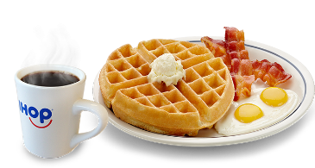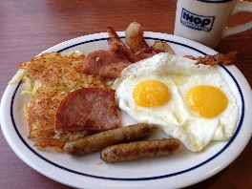
*Use a gift card purchased through the school office and help the school earn an additional 7.74% back. Limited quantities available.

Join us for MVCA Spirit Night at
(Route 50 – Winchester)

Come join us for great food and fellowship and support a great cause – the Mountain View Christian Academy PTF. IHOP will donate 10% of all sales between those hours.

When: Monday, October 16
5:00 pm – 8:00 pm
Who: All MVCA families and friends.

*Use a gift card purchased through the school office and help the school earn an additional 7.74% back. Limited quantities available.

