[](http://mvca.ccmv.com/)

2015 – 2016 Year End NewsLetter



God’s CHANGELESS TRUTH

*changes* lives for eternity!

**Changeless Truth -** That was our annual theme and as seems to be the case with every year, our theme ends up holding so true to the events that transpire. We chose this theme knowing that we are living in a world that is constantly changing, a world where most people do not believe in absolute truth. Yet…we serve an amazing God that never changes and his truth is changeless! We began the year with change - several new students coming together from various Christian schools, home schooling, and public school; our prayer was that we could assimilate the students and become one body of believers united in purpose by God’s Changeless Truth. It has been a blessing to see that merging happen. As we went through the year, we sadly, experienced a change that we never would have imagined – on February 25, 2016, Christopher Saville, one of our seniors, went into eternity. Praise the Lord, he had accepted God’s Changeless Truth so we could rejoice through the sorrow claiming that God’s promises are true. Christopher, like so many others in his class as well as in the school followed through the steps of our theme – seek the truth, know the truth, speak the truth, live the truth! Through the events of this school year, we have come to see that ***God’s Changeless Truth changes lives***. That truth has characterized this year! I know of 20 individuals affiliated in some way with Mountain View Christian Academy who sought truth, came to know it, surrendered their lives in baptism to Christ’s Lordship, and began to speak and live in truth – 15 students, 2 alumni, 2 family members, and 1 friend of our students. There may be others that I am not aware of, but I know that in 24 years of working with this ministry, I have never known of that many of our school constituency making their decision for Christ in the school year! Praise the Lord for His amazing, changeless truth! May Mountain View Christian Academy always hold to that fact that there is absolute truth that stands in a changing world that believes that truth is relative – ***Jesus Christ is the same yesterday, today, and forever!***

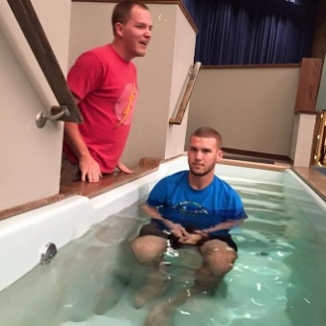

**JUNE**

**Tues, 14 –**MVCA Entrance Diagnostic Testing (8am-3 pm)

**Sat, 25** – MVCA Open House (12-8pm)

**27-July 1** – MVCA ACT Test Prep Camp (9am-12pm)

**Thurs, 30** – MVCA Enrollment Interviews

**JULY**

**5-29 –**MVCA Summer School Enrichment (9am-12 pm)

**11-15** – MVCA Math Fitness Camp (9am-12pm**)**

**11-15** – MVCA Kinder Camp (9am-12pm**)**

**18-22** – MVCA Basketball Camp (9am-12pm**)**

**Mon, 18 –**MVCA Entrance Diagnostic Testing (8am-3 pm)

**25-29** – MVCA Chinese Discovery Camp (9am-12pm**)**

**Mon, 25** – MVCA Open House (12-8pm)

**Tues, 26** – MVCA Enrollment Interviews

**Thurs, 28** – MVCA Enrollment Interviews

**August**

**Fri, 12 –**MVCA International Host Family Orientation (7pm))

**Mon, 22** – MVCA Meet the Teacher (6:30 pm)

**Wed, 24** – MVCA 1st Day of School

**Summer Dates**

**Celebrating National School Choice Week – we believe in parental choice to make decisions to educate their children in the way they feel is best.**

**Mountain View Christian Academy**

**Summer Open House**

**June/July 25 – 12 to 8 pm**

**You’re Invited!**

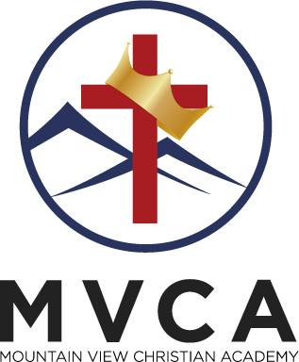

**Summer Open House – 2 Opportunities**

This is your opportunity to “tell your MVCA story” to everyone you know. Our best advertising and marketing is word of mouth. Please help us spread the word about our school! We are so excited for the 2016-2017 school year! It is already shaping up to be another banner year! **As we prepare to celebrate our 25th year anniversary, we have set a goal to increase our enrollment by 25 students!** We ended this year with 175, so that would give us an exciting enrollment of 200 students!

As always we are praying that God will bring us right fit families who will embrace our mission, vision, and philosophy and who will be impacted for eternity by being a part of the MVCA school family.

So plan to come out yourself and bring friends, family members, neighbors, anyone who may be interested in seeing the difference that a Christ-centered education can make in their lives.

**In honor of the upcoming 25th anniversary, we will host our two Open Houses on Saturday, June 25, and Monday, July 25, from noon to 8:00 p.m.** Folks can stop by anytime for tours, fellowship, and refreshments.

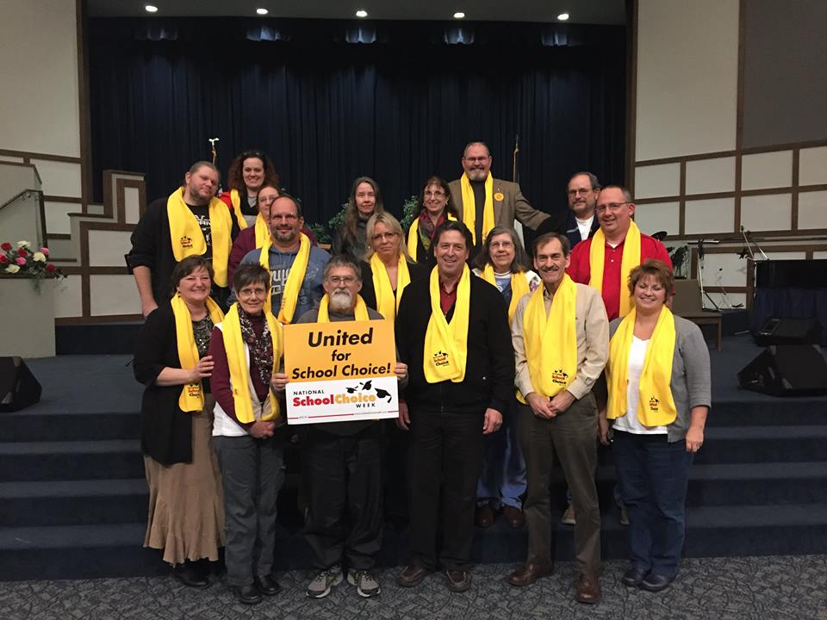

*At MVCA, we are honored when parents trust us to partner with them in their child(ren)’s education!*

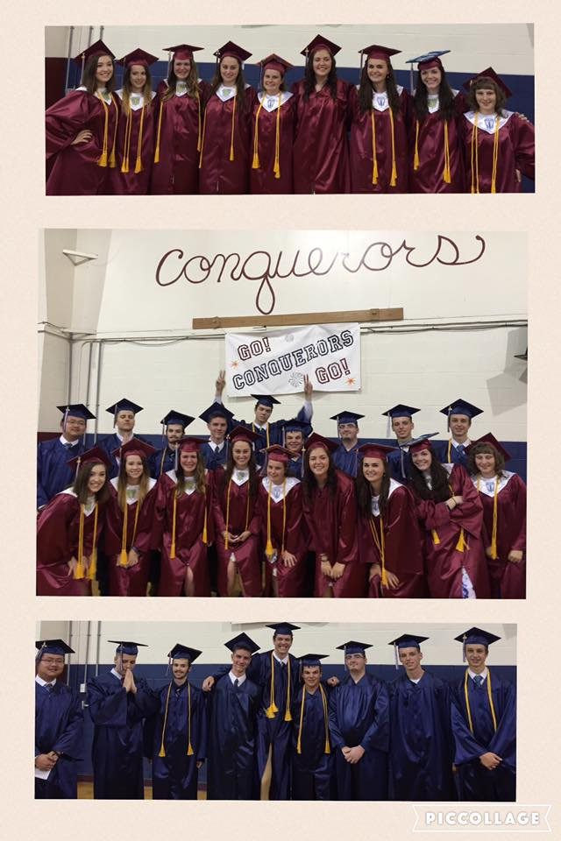

**Congratulations 2016 Graduating Class!**

Please keep our 18 graduates in prayer as they take what they have learned at MVCA out into college and career. This is an incredible group of young men and women. You can see from the picture above the many honor cords and National Honor Society stoles. This group had 6 individuals graduate Summa Cum Laude with G.P.A.’s at or above a 4.0. **Congratulations to Madison Myers, our valedictorian, and Grace Baggett and Jakub Kulakowski, our co-salutatorians!** Expect big things from this group of CHANGED young men and women!

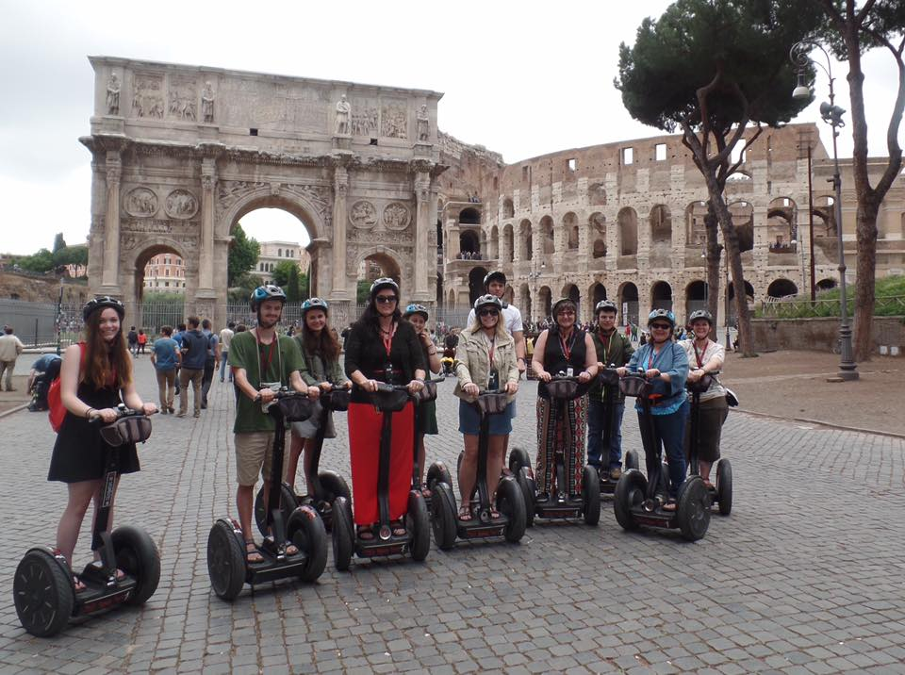

**2016 Senior Trip to Europe**

At Mountain View, one of the many privileges is the senior trip we take every year to Europe. The students help plan the itinerary and we spend 10-14 days together experiencing world and biblical history firsthand. Here we are on Segways with the Roman Coliseum and the Arch of Constantine behind us. This year’s trip was an incredible look at World War II history from London to Berlin and on to Italy, including the beaches of Normandy and many famous battlefields. It was amazing to see the sacrifice so many made to change the course of history. We finished off with the ancient ruins and biblical history here in Rome! Being in Europe totally shows how Jesus rocked the world and now measures time – AD and BC.

**“God, Grades, Game!”**

That is the motto of our athletic program and we pray that every student athlete at MVCA learns to prioritize in that way. Our students reflect the attitude and character of Christ on the courts and fields. We are proud of their accomplishments!

*“…in all these things we are more than CONQUERORS.”* Romans 8:37

**“You will never be a leader until you are treated like a servant and don’t notice it.”**

Jesus was the most incredible leader who ever walked the face of this earth, yet He came to serve. At Mountain View we strive to develop “servant leaders” like Christ who can truly make an impact and a difference in our world!

*MVCA’s 175 students reported 5,566.75 service hours this year!*

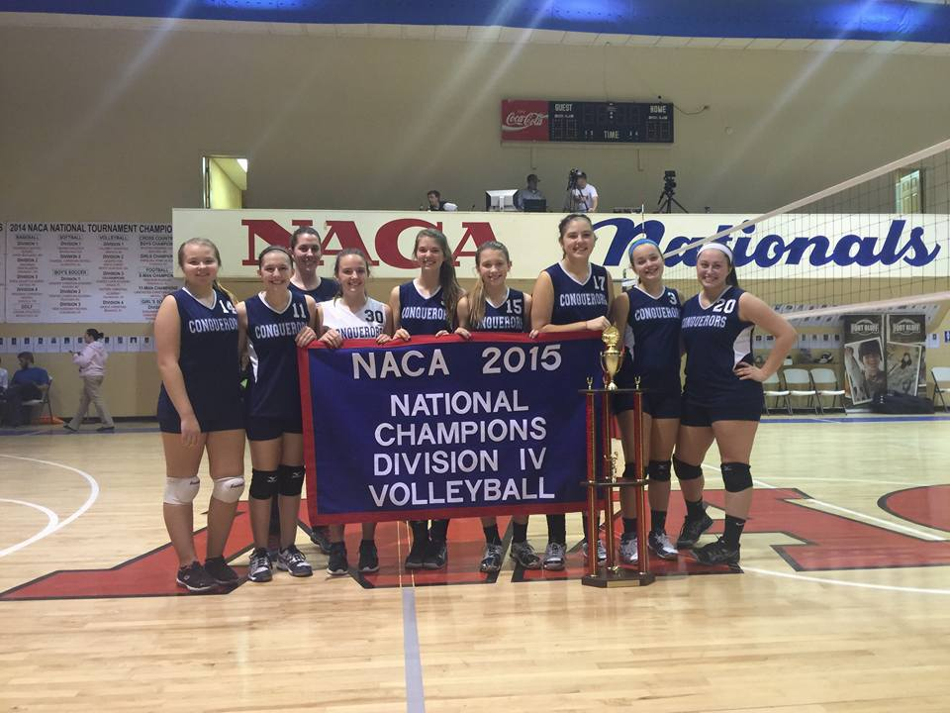

**Our Athletic Program -** This year Mountain View Christian Academy was able to field soccer, volleyball, basketball, cheer, baseball, flag football, cross country, and track teams. Many of these teams experienced competitive improvement and some achieved great successes.  Highlights of this year include the following: **the varsity volleyball team won the D4 National Championship at NACA in Dayton, TN** (see picture above); the varsity boys cross country team won its first ever meet against public schools; **the middle school boys cross country team finished as regular and tournament champions in the Valley Middle School Conference**; the baseball team, varsity boys soccer team, and girls soccer team won more games this season than any of the past five seasons; **the baseball team and girls soccer team both won the Sportsmanship Awards at NACA in Dayton, TN**. All sports teams maintained a cumulative team average GPA of 3.1 or higher, with the JV volleyball team maintaining a 3.874 GPA.

Various school records were set by both middle school and varsity athletes in track and cross country. **In addition, several individual athletes received national honors at the various NACA tournaments in Dayton, TN**: Jackie Coughlin - D4 Most Valuable Offensive Player, selected as All-American;  Helena Higgins - D4 Most Valuable Setter, selected as All-American; Kooper Anderson - D2 All-Tournament Team; Hallie Dhom - D2 All-Tournament Team; Kaitlin Santmyers - D2 All-Tournament Team. Jakub Kulakowski and Kaitlin Santmyers were MVCA's First Scholar Athlete recipients for athletes who maintained the highest GPA average during the year.

Sports camps and open gyms will be held through the summer. Watch for emails with additional information.



**2015-2016 Serve-a-Thon Hours and Projects -** 2015-2016 was another great year for service at MVCA! The school helped 12 different organizations including MVCA, New Life Christian Church, Evan’s Children’s Home, Home Instead, The Salvation Army, Southside Church of Christ, Grundy Mountain Mission School, U.S. military personnel, The Church of Christ at Mountain View, Campamento Canaan (Salcedo, Dominican Republic – pictured above), the local food bank, and Tri-State Christian Service Camp! Students made 197 homemade Christmas cards for our military personnel and our families donated 70 pairs of pajamas, 1,897 pounds of food, and 17 blankets to various organizations. Students worked individually in their own communities and churches and reported 1, 385.5 hours served and as classes or groups served a total of 4,181.25 hours on school-planned activities. **Our students were the hands and feet of Jesus this year for a total of 5, 566.75 hours!** Thank you to all who helped make this incredible year of service possible!



**JUNE**

**Tues, 14 –** CCMV Terrific Tuesday Pool Party

**Fri, 17** – CCMV Father’s Day Campout

**19-22** – “Game Night” – CCMV Teen Camp

**Tues, 21** - CCMV Terrific Tuesday Bowling

**22-24** – “Avengers of the Truth” – CCMV Children Camp

**Tues, 28** - CCMV Terrific Tuesday Pool Party

**JULY**

**Tues, 12 –** CCMV Terrific Tuesday Movies

**Tues, 19** - CCMV Terrific Tuesday Pet Farm

**17-22** – “CIY MOVE” – CCMV Teen event

**Tues, 26** - CCMV Terrific Tuesday Pool Party

**AUGUST**

**7-12** –CCMV Vacation Bible School

Contact the Church Office at **540-869-2244** for more information.

Linette Ritter – Children’s Ministry

Nathan Wright – Youth Ministry

MVCA is a ministry of the Church of Christ at Mountain View. We invite you to come worship with us anytime!

**Church of Christ at Mountain View (CCMV) SUMMER Events**

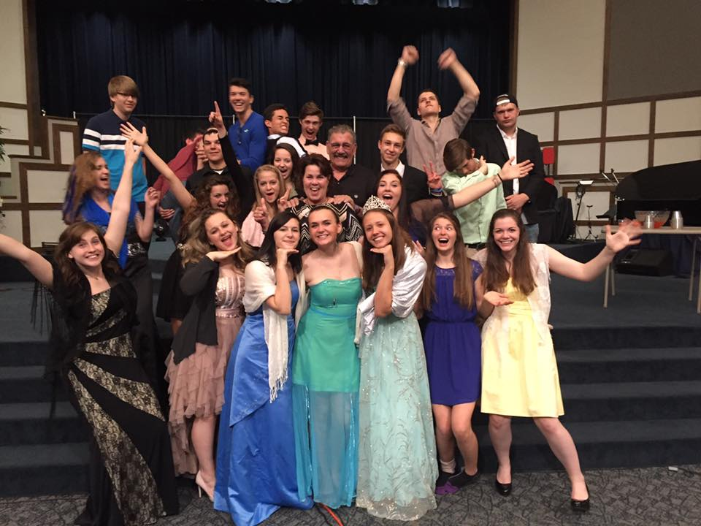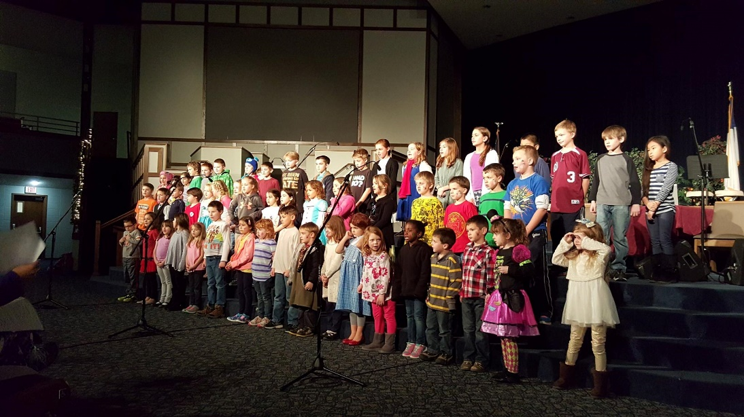

**Fine Arts Opportunities – Programs and Performances –** Our students with their respective music and drama instructors, once again did an amazing job with their combined Christmas program and individual spring programs. All elementary students have the opportunity to participate in these 2 live performances, building their confidence and teaching them to be leaders. Secondary students can choose a fine arts elective and become part of a drama team that shares skits and sketches at various events throughout the year and culminates in the spring production that they write at a drama/writer’s retreat. This year’s production of ONE LIFE took on a new and special meaning after their classmate’s death. The production was presented in loving memory of Christopher Saville and the impact that one life changed by the amazing power of Jesus Christ has on so many.



**MVCA’s International Program** – That is probably one of my favorite family pictures with my Korean son and my Dominican son-in-law and my immediate birth family. I also have the privilege of calling a young German girl my daughter. Through our international exchange program, students from all over the world get to experience American culture and be exposed to God’s changeless truths, many of them for the first time. In exchange, our families and students get to experience world cultures and develop a global understanding. This year we hosted students from 7 different countries – Poland, Bulgaria, Thailand, Norway, Korean, China, and Japan! We have students who come for 1 year only and students who come for 4 or more (in my case, Danielson, as we affectionately call him, came for 1 year and is now on his 8th year as part of our family!) Contact the office today at 540-868-1231 if you are interested in this program. It truly can be a wonderful, life-changing experience for all parties. Stipends are available for families who participate.

**Experience the joys of an amazing cultural exchange with MVCA’s International Program.**

**Contact the office today and save the date - August 12 - for Host Family Orientation**

**Deep Appreciation and Sad Goodbyes –** Mrs. Brenda Heselton and Mrs. Marjorie Baggett will be leaving our full time faculty after 18 and 9 years of service, respectively. Both will still be involved through substituting and activities. In addition, we are thankful for the service of Mrs. Melanie Jackson who will be leaving as our elementary aid and PE teacher, but also still involved as a parent. A huge void will need to be filled as Karen Karoghlanian, our PTF president of 3 years will be stepping down from that role. All of these women have been extremely instrumental at MVCA!

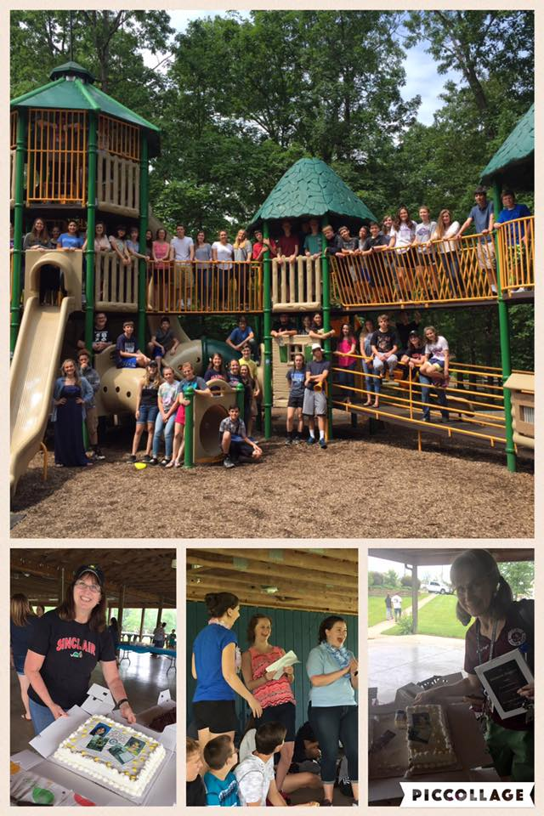



**I Stand With God –** One of our 2012 graduates, Jordon McMullen, has started a ministry to encourage people to pray fervently and without ceasing for our country. Go to [**http://www.istandwithgod.net/**](http://www.istandwithgod.net/) to sign up for FREE daily devotional and prayer thoughts.